TASK 1:

Regular expressions are powerful tool for pattern matching text they help in :

* Searching
* Validating
* Extracting
* Replacing

. Any single character except newline

*0 or more repetitions ab*c -> “ac”, “abc”

+ 1 or more repetitions ab+c -> “abc” , “abbc”

? 0 or 1 occurrence colou?r -> “color”, “colour”

{n} Exactly n repetitions a{3} -> “aaa”

$ End of a string World$ -> “World” at the end

^ Start of a string ^Hello -> “Hello” at the start

**Task 2: What are the Features of Linux?**

Linux is a powerful, open-source operating system widely used in servers, desktops, and embedded systems. Here are its key features:

1. Open Source & Free

* Linux is freely available under GNU GPL (General Public License).
* Users can modify and redistribute the code.

2. Multi-User & Multi-Tasking

* Multiple users can work simultaneously (via terminals).
* Supports running multiple processes at the same time.

3. High Security

* Built-in firewall
* User permission system restricts unauthorized access.

4. Stability & Reliability

* Linux servers run for years without rebooting (unlike Windows).
* Handles heavy workloads efficiently (used in supercomputers).

5. Customizability

* Multiple distributions (Ubuntu, Fedora, Arch, etc.) for different needs.
* Users can choose their desktop environment (GNOME, KDE, etc.).

6. Lightweight & Efficient

* Runs smoothly on old hardware (unlike Windows 11).
* Uses fewer system resources (RAM, CPU).

7. Strong Networking

* Excellent for servers (Apache, Nginx, SSH, FTP).
* Supports containerization (Docker, Kubernetes).

8. Command-Line Power (Terminal)

* Bash scripting automates tasks.
* SSH allows remote control of servers.

**Task 3: What is a Kernel?**

**Kernel** is the **core part of the operating system**. It acts as a **bridge** between the hardware and the software.

#### Example:

When you open a file:

* The **application** asks the **kernel**.
* The **kernel** tells the **hardware** to fetch it.
* Then it sends the file back to the app.

**TASK 4**

**BASH** stands for **Bourne Again SHell**.

* It is the default command-line interface (CLI) used in most Linux systems.
* A shell is a program that lets you interact with the operating system by typing commands.
* BASH is an enhanced version of the original Bourne Shell (sh), with more features.
* It allows users to:
  + Navigate files and folders
  + Run and manage programs
  + Write and execute shell scripts for automation

Think of BASH as a translator between **you** and the **Linux system** — you type commands, it gets things done.

Task 5: Difference Between Linux and Windows

**Linux**

Linux is a free and open-source operating system. This means anyone can download it, use it, and even change its code. It’s very flexible and can be customized however you want. Linux gives you more control over your system and is mainly used by developers, IT professionals, and for running servers. It uses a terminal (command-line interface) along with a normal screen (graphical interface). It's very safe, lightweight, and doesn't slow down your computer. Also, it treats files carefully — "File.txt" and "file.txt" are not the same.

**Windows**

Windows is a paid operating system made by Microsoft. You can’t change its code, and you need to buy a license to use it fully. It’s made for normal users and is easy to use with a simple graphical screen (GUI). Most home computers use Windows. It supports games and apps well but uses more memory and can slow down older systems. It’s not as secure as Linux and can easily get viruses. Also, in Windows, file names like "File.txt" and "file.txt" are treated as the same.

**Task 6: Basic Components of Linux (Simple Explanation)**

Linux has 5 main components. Think of Linux like a layered system:

1. **Kernel** – The Core

* The brain and heart of Linux.
* It talks directly to the hardware.
* Manages memory, CPU, devices, and processes.

2. **Shell** – The Command Interface

* A program that takes commands from users and passes them to the kernel.
* Examples: BASH, ZSH.

Allows automation through scripting.

3. **File System** – Organized Storage

* Everything in Linux is treated as a file.
* The system is structured like a tree, starting from the root directory /.

4. **System Libraries** – Code Helpers

* These are special files that programs use to communicate with the kernel.
* They make programming and system functions easier.

5. **Utilities & Applications** – User Tools

* These are command-line tools (ls, cp, mv) and GUI programs (text editors, web browsers).
* They help perform tasks like browsing files, editing text, or checking system info.

We can Think of Linux like a well-organized team:  
Kernel (leader), Shell (interpreter), File System (storage), Libraries (assistants), Utilities (tools).

**Task 8: What is LILO?**

**LILO (Linux Loader)** is a **boot loader** for Linux. It loads the Linux operating system into memory when the computer starts. It can also load other operating systems like Windows. LILO stores boot information in the MBR (Master Boot Record) and does not need a filesystem to boot.

**Task 9: What is Shell? Types of Shells**

A **shell** is the program that takes your commands (like ls, mkdir, etc.) and tells the system what to do.

There are many shells, but the main ones are:

* **Bash** (Bourne Again Shell) – Most common in Linux.
* **Sh** (Bourne Shell) – Older version of Bash.
* **Ksh** (Korn Shell) – Useful for scripting.
* **Csh** (C Shell) – Syntax similar to C programming.
* **Zsh** (Z Shell) – Advanced shell with plugins and themes.

**Task 10: What is Swap Space?**

**Swap space** is like extra virtual memory. If your RAM is full, Linux moves some data to the swap space to free up RAM. It's stored on your hard drive and helps avoid crashes when you run out of memory.

**TASK 11: What is Mount in Linux?**

**Mounting** means making a storage device (like USB, CD, or partition) available to use in the Linux system. When you mount a device, Linux connects it to a directory so you can access its files.

**TASK 12: WHAT IS CHMOD COMMAND? HOW TO USE IT?**

chmod stands for **"change mode"** and is used to **change the permission** of a file or directory in Linux.

Each file has three types of permissions:

* **r** → read
* **w** → write
* **x** → execute

**Task 13: How to Add a New User?**

1. **Using adduser**

You can create a new user in multiple ways.

Sudo adduser newusername

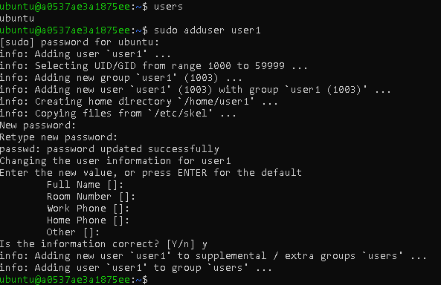

2. Using useradd:

Sudo useradd -m newusername

Sudo passwd newusername

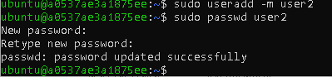

**Task 14: How to Change Password of a User?**

To change a password, use:

Sudo passwd username

Then it will ask to enter and re enter the new password



Task 15: Difference Between Process and Thread

Process:

* A **process** is an **independent program** in execution.
* It has its **own memory**, files, and system resources.
* Example: Opening Chrome creates a process.

**Thread**:

* A **thread** is a **smaller unit** of a process.
* All threads in a process **share the same memory**.
* Example: In Chrome, one thread loads the page, another plays audio.

In simple words: **Process = a full app,  
Thread = a task inside that app**.

Task 16: Document 14 Linux grep commands in "docs to study" folder

1. grep "Linux" sample.txt

2. grep -i "linux" sample.txt - # Case-insensitive search

3. grep -v "Linux" sample.txt - # Show lines not matching

4. grep -n "Linux" sample.txt - # Show line numbers

5. grep -c "Linux" sample.txt - # Count occurrences

6. grep -r "Linux" . # Search in all files recursively

7. grep -l "Linux" * # List files containing word

8. grep -w "Linux" sample.txt # Match whole word only

9. grep -o "Linux" sample.txt # Show only matched words

10. grep -e "Linux" -e "Bash" sample.txt # Multiple patterns

11. grep "^Linux" sample.txt # Lines starting with "Linux"

12. grep "tool$" sample.txt # Lines ending with "tool"

13. grep "[Tt]hread" sample.txt # Match pattern with either case

14. grep -A 1 "grep" sample.txt # Show line after match

Administrator@a0537ae3a1875ee MINGW64 /d/Atlas-D5/Linux Practice

$ cat > hellofile.txt

unix is great os. unix was developed in Bell labs.

learn operating system.

Unix linux which one you choose.

uNix is easy to learn.unix is a multiuser os.Learn unix .unix is a powerful.

Administrator@a0537ae3a1875ee MINGW64 /d/Atlas-D5/Linux Practice

$ cat hellofile.txt

unix is great os. unix was developed in Bell labs.

learn operating system.

Unix linux which one you choose.

uNix is easy to learn.unix is a multiuser os.Learn unix .unix is a powerful.

Administrator@a0537ae3a1875ee MINGW64 /d/Atlas-D5/Linux Practice

$ grep -i "UNix" hellofile.txt

unix is great os. unix was developed in Bell labs.

Unix linux which one you choose.

uNix is easy to learn.unix is a multiuser os.Learn unix .unix is a powerful.

Administrator@a0537ae3a1875ee MINGW64 /d/Atlas-D5/Linux Practice

$ grep -c "unix" hellofile.txt

2

Administrator@a0537ae3a1875ee MINGW64 /d/Atlas-D5/Linux Practice

$ grep -l "unix" hellofile.txt

hellofile.txt

Administrator@a0537ae3a1875ee MINGW64 /d/Atlas-D5/Linux Practice

$ grep -w "unix" hellofile.txt

unix is great os. unix was developed in Bell labs.

uNix is easy to learn.unix is a multiuser os.Learn unix .unix is a powerful.

Administrator@a0537ae3a1875ee MINGW64 /d/Atlas-D5/Linux Practice

$ grep -o "unix" hellofile.txt

unix

unix

unix

unix

unix

Administrator@a0537ae3a1875ee MINGW64 /d/Atlas-D5/Linux Practice

$ grep -n "unix" hellofile.txt

1:unix is great os. unix was developed in Bell labs.

4:uNix is easy to learn.unix is a multiuser os.Learn unix .unix is a powerful.

Administrator@a0537ae3a1875ee MINGW64 /d/Atlas-D5/Linux Practice

$ grep -v "unix" hellofile.txt

learn operating system.

Unix linux which one you choose.

Administrator@a0537ae3a1875ee MINGW64 /d/Atlas-D5/Linux Practice

$ grep "^unix" hellofile.txt

unix is great os. unix was developed in Bell labs.

Administrator@a0537ae3a1875ee MINGW64 /d/Atlas-D5/Linux Practice

$ grep "0s$" hellofile.txt

Administrator@a0537ae3a1875ee MINGW64 /d/Atlas-D5/Linux Practice

$ grep "0s.$" hellofile.txt

Administrator@a0537ae3a1875ee MINGW64 /d/Atlas-D5/Linux Practice

$ grep "os.$" hellofile.txt

Administrator@a0537ae3a1875ee MINGW64 /d/Atlas-D5/Linux Practice

$ grep "ul.$" hellofile.txt

uNix is easy to learn.unix is a multiuser os.Learn unix .unix is a powerful.

Administrator@a0537ae3a1875ee MINGW64 /d/Atlas-D5/Linux Practice

$ cat hellofile.txt

unix is great os. unix was developed in Bell labs.

learn operating system.

Unix linux which one you choose.

uNix is easy to learn.unix is a multiuser os.Learn unix .unix is a powerful.

Administrator@a0537ae3a1875ee MINGW64 /d/Atlas-D5/Linux Practice

$ grep -e "Moinuddin" -e "Moin" -e "Mohd" hellofile.txt

Administrator@a0537ae3a1875ee MINGW64 /d/Atlas-D5/Linux Practice

$ cat hellofile.txt

unix is great os. unix was developed in Bell labs.

learn operating system.

Unix linux which one you choose.

uNix is easy to learn.unix is a multiuser os.Learn unix .unix is a powerful.

Administrator@a0537ae3a1875ee MINGW64 /d/Atlas-D5/Linux Practice

$ echo -e "Moinuddin\nMoin\nMohd" > pattern.txt

Administrator@a0537ae3a1875ee MINGW64 /d/Atlas-D5/Linux Practice

$ grep -A1 "learn" hellofile.txt

learn operating system.

Unix linux which one you choose.

uNix is easy to learn.unix is a multiuser os.Learn unix .unix is a powerful.

Administrator@a0537ae3a1875ee MINGW64 /d/Atlas-D5/Linux Practice

$ grep -iR "Hellos" /home/hellos

grep: /home/hellos: No such file or directory

Administrator@a0537ae3a1875ee MINGW64 /d/Atlas-D5/Linux Practice

$ grep -i "Mohammad" file5.txt

Hi This is Mohammad Moinuddin

Administrator@a0537ae3a1875ee MINGW64 /d/Atlas-D5/Linux Practice

$ grep -i "grep" file5.txt

Samole for grep

Administrator@a0537ae3a1875ee MINGW64 /d/Atlas-D5/Linux Practice

$ grep -l "grep" file5.txt

file5.txt

Administrator@a0537ae3a1875ee MINGW64 /d/Atlas-D5/Linux Practice

$ grep -l "Moin" file5.txt

file5.txt

Administrator@a0537ae3a1875ee MINGW64 /d/Atlas-D5/Linux Practice

$ grep -n "Moin" file5.txt

1:Hi This is Mohammad Moinuddin

2:hi this is Moin

Administrator@a0537ae3a1875ee MINGW64 /d/Atlas-D5/Linux Practice

$ grep -v "Moin" file5.txt

Samole for grep

Administrator@a0537ae3a1875ee MINGW64 /d/Atlas-D5/Linux Practice

$ grep -e "Moin" file5.txt

Hi This is Mohammad Moinuddin

hi this is Moin

Administrator@a0537ae3a1875ee MINGW64 /d/Atlas-D5/Linux Practice

$ grep -f "Moin" file5.txt

grep: Moin: No such file or directory

Administrator@a0537ae3a1875ee MINGW64 /d/Atlas-D5/Linux Practice

$ grep -E "Moin" file5.txt

Hi This is Mohammad Moinuddin

hi this is Moin

Administrator@a0537ae3a1875ee MINGW64 /d/Atlas-D5/Linux Practice

$ grep -w "Moin" file5.txt

hi this is Moin

Administrator@a0537ae3a1875ee MINGW64 /d/Atlas-D5/Linux Practice

$ grep -o "Moin" file5.txt

Moin

Moin

Administrator@a0537ae3a1875ee MINGW64 /d/Atlas-D5/Linux Practice

$ grep -A 2 "Moin" file5.txt

Hi This is Mohammad Moinuddin

hi this is Moin

Samole for grep

Administrator@a0537ae3a1875ee MINGW64 /d/Atlas-D5/Linux Practice

$ grep -B 2 "Moin" file5.txt

Hi This is Mohammad Moinuddin

hi this is Moin

Administrator@a0537ae3a1875ee MINGW64 /d/Atlas-D5/Linux Practice

$ grep -C 2 "Moin" file5.txt

Hi This is Mohammad Moinuddin

hi this is Moin

Samole for grep

**Task 17:**

**AWK commands in doc 15 Linux AWK commands**.

Administrator@a0537ae3a1875ee MINGW64 /d/Atlas-D5/Linux Practice

$ cat file6.txt

10 apple 100

20 banana 150

30 cherry 200

40 date 250

50 elderberry 300

Administrator@a0537ae3a1875ee MINGW64 /d/Atlas-D5/Linux Practice

$ awk '{print}' file6.txt

10 apple 100

20 banana 150

30 cherry 200

40 date 250

50 elderberry 300

Administrator@a0537ae3a1875ee MINGW64 /d/Atlas-D5/Linux Practice

$ awk '{print $1, $3}' file6.txt

10 100

20 150

30 200

40 250

50 300

Administrator@a0537ae3a1875ee MINGW64 /d/Atlas-D5/Linux Practice

$ awk /banana/'{print}' file6.txt

20 banana 150

Administrator@a0537ae3a1875ee MINGW64 /d/Atlas-D5/Linux Practice

$ awk '{sum +=$3} END{print sum}' file6.txt

1000

Administrator@a0537ae3a1875ee MINGW64 /d/Atlas-D5/Linux Practice

$ awk '{print substr($1, 1,2)}' file6.txt

10

20

30

40

50

Administrator@a0537ae3a1875ee MINGW64 /d/Atlas-D5/Linux Practice

$ awk '{print substr($3, 1,2)}' file6.txt

10

15

20

25

30

Administrator@a0537ae3a1875ee MINGW64 /d/Atlas-D5/Linux Practice

$ awk 'NR==FNR{a[$1]=$2; next} {print $0, a[$1]}' file6.txt file7.txt

awk: cmd. line:1: fatal: cannot open file `file7.txt' for reading (No such file or directory)

Administrator@a0537ae3a1875ee MINGW64 /d/Atlas-D5/Linux Practice

$ awk 'NR==FNR{a[$1]=$2; next} {print $0, a[$1]}' file6.txt Pr1.txt

Administrator@a0537ae3a1875ee MINGW64 /d/Atlas-D5/Linux Practice

$ awk '{print $1}' file6.txt

10

20

30

40

50

Administrator@a0537ae3a1875ee MINGW64 /d/Atlas-D5/Linux Practice

$ awk '{sum +=$1} END {print sum / NR}' file5.txt

0

Administrator@a0537ae3a1875ee MINGW64 /d/Atlas-D5/Linux Practice

$ awk '{sum +=$1} END {print sum / NR}' file6.txt

30

**Task 18:**

**How to check file access permission in Linux?**

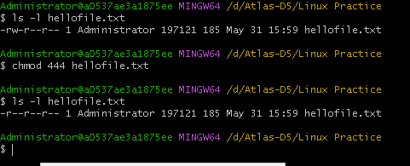

**Task 19:**

**What are the default permissions for a new file ?**

By default, for **regular files**, the permissions are:

* **Owner** → rw- (read + write)
* **Group** → r-- (read only)
* **Others** → r-- (read only)

**Task 20:**

**What is the command to change the permission to read only for the owner, group and all other users**



**TASK 20-25:**

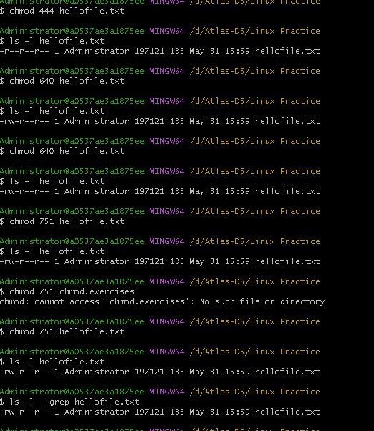

**Task 26: What is a Process in Linux?**

A **process** is a program that is currently **being executed**. It is an instance of a running program.

**Task 27:**

**What is command to check foreground process and background process**

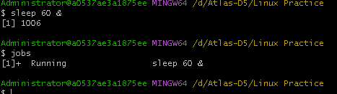

**Task 28:**

**Can you list all the running processes?**

**Hint use ps**

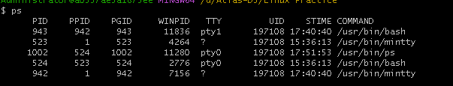

**Task 29:**

**What will ps -f command do ?**

The ps -f command in Linux displays **detailed information about processes** in a **full-format listing**.

dministrator@a0537ae3a1875ee MINGW64 /d/Atlas-D5/Linux Practice

$ ps -f

UID PID PPID TTY STIME COMMAND

Administ 943 942 pty1 17:40:40 /usr/bin/bash

Administ 523 1 ? 15:36:13 /usr/bin/mintty

Administ 1013 524 pty0 17:59:11 /usr/bin/ps

Administ 524 523 pty0 15:36:13 /usr/bin/bash

Administ 942 1 ? 17:40:40 /usr/bin/mintty

[1]+ Done sleep 60

**TASK 30-32**

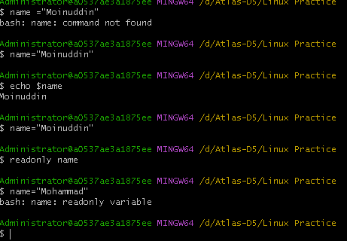

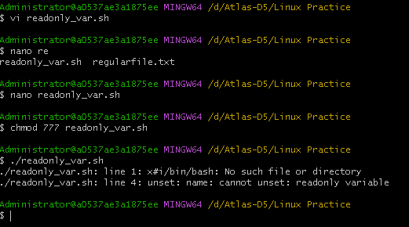

**TASK 33-3:**

**CAn u try to add a list of your friends names in an array and try to printout?**

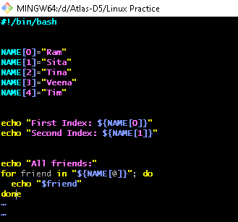

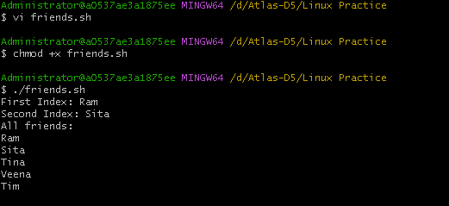

**Task 34:**

**Can you print all the list at once in an array? YES**

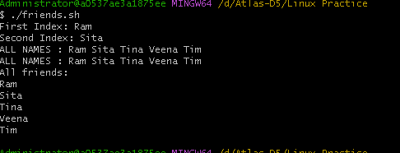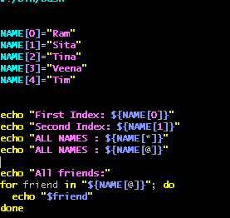

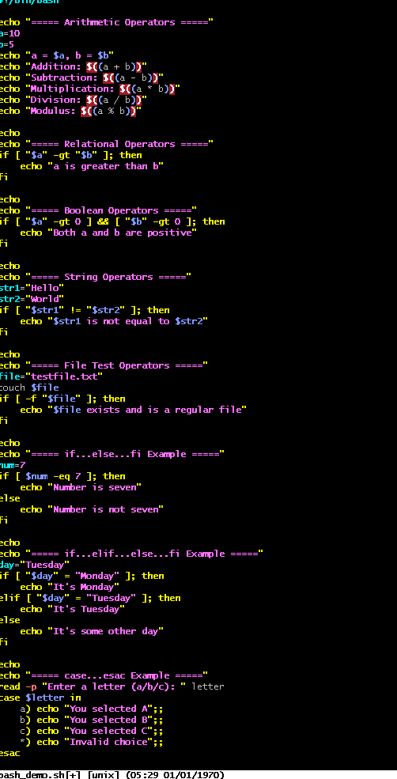

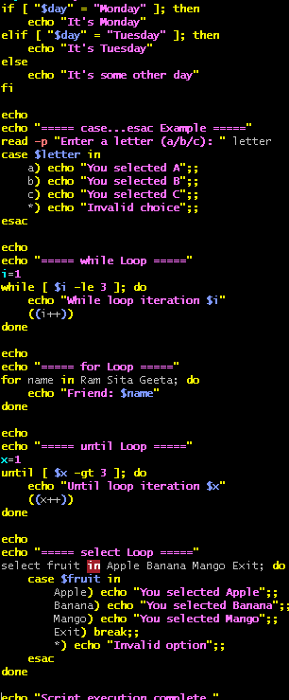

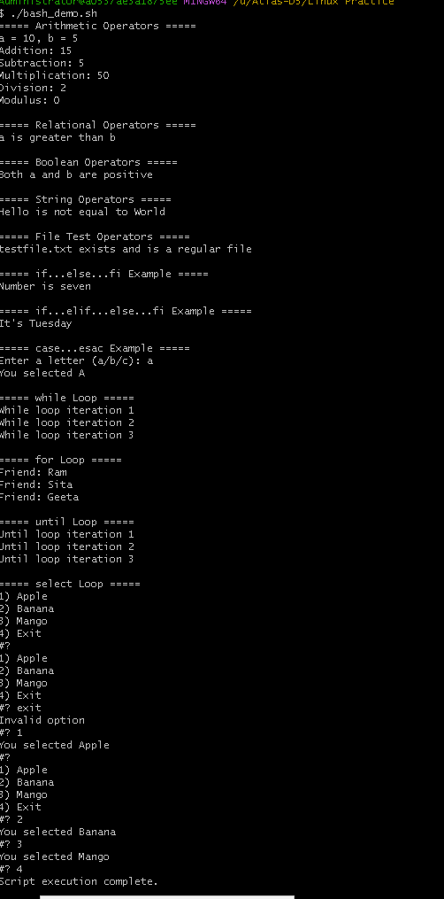

**Task 35:**

